# Solving Challenge 1: Dream Theater Fan Files

1. At the beginning, we see a single mp3 file named *riddle1.mp3*

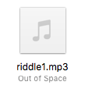

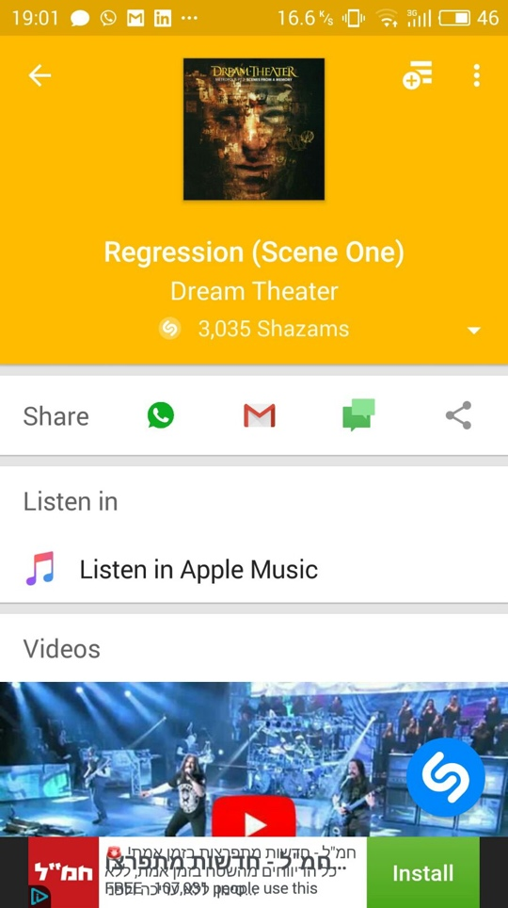

1. After playing it, if not recognize the song use ** that tells you: the name of the song, the name of the album that the song belongs to, and the name of the band.
2. Open terminal and unzip the song:



1. Now we got 13 images of 13 Dream Theater albums artworks:

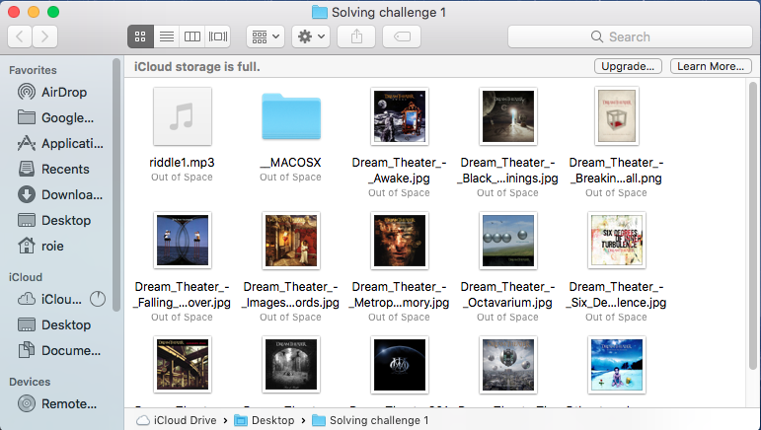

1. Recognizing the album-artwork we discovered using Shazam:

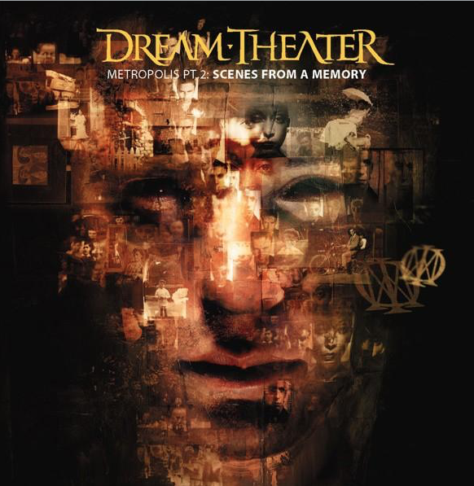

1. Unzipping this picture will give us new 3 black and white pictures:

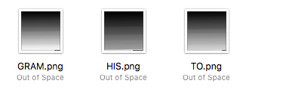

1. Those pictures names create the word “Histogram” which is the graph that shows the different amounts of colors in the picture.
2. Using <http://pinetools.com/image-histogram> we can see those pictures histograms:

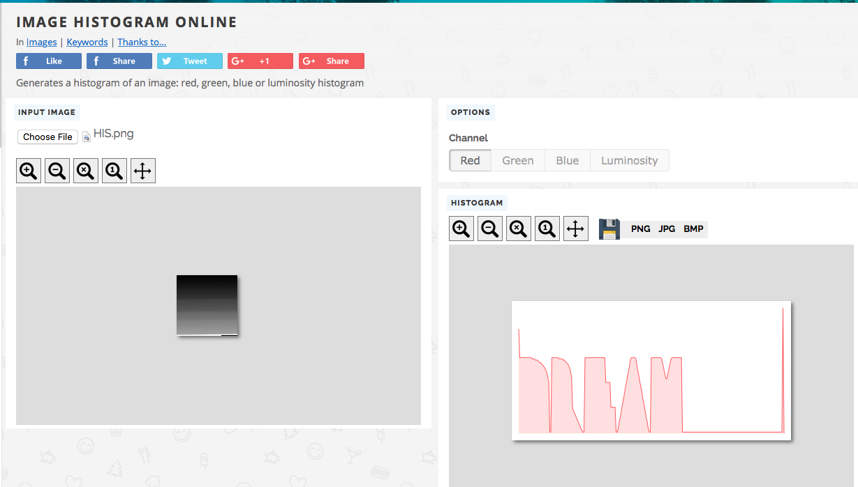HIS.png -> DREAM

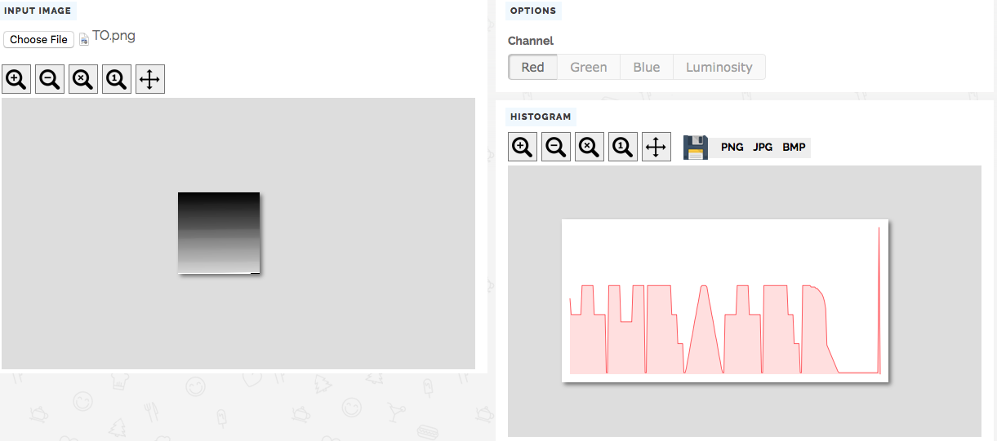TO.png -> THEATER

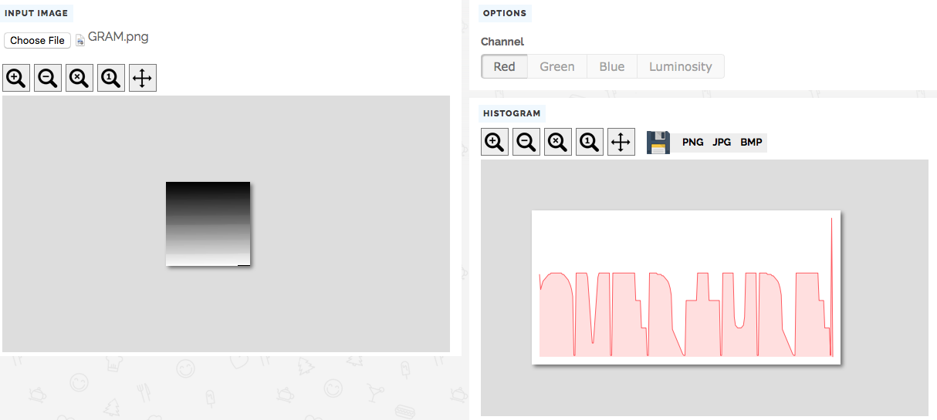GRAM.png -> OVERTURE

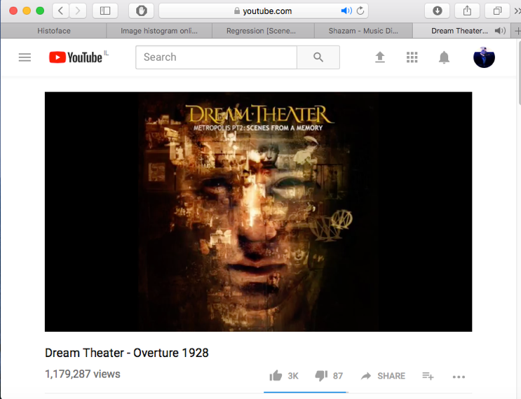

And that’s it, the song is: Dream Theater - Overture 1928.